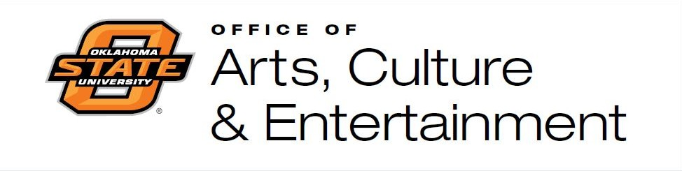
Student Union Gallery
Artist Agreement to Exhibit

1. The Student Union Gallery is the art gallery of Oklahoma State University’s Student Union (OSU).

2. The Gallery is not a commercial entity and all sales must be negotiated directly with the artists. The Gallery receives no percentage of any sales that might occur.

3. OSU Student Union Gallery is not responsible for damaged or stolen works at any time during the hanging or taking down or during the exhibition itself.

4. Exhibiting artists are responsible for framing their own work, delivering and picking up their work at the agreed time.

5. Gallery openings are optional with OSU providing refreshments, which can of course be supplemented by the exhibiting artist. If the artist wishes to add to the refreshments, he/she must purchase it from Student Union Celebration’s Catering who can be reached at (405) 744-7053. The duration of exhibitions are at the discretion of the Gallery director. The exhibiting artist is encouraged to invite their own guests to receptions, and the Office of Arts, Culture, & Entertainment will market the reception to the OSU and Stillwater community.

6. The Gallery Director will determine which works are chosen and how they will be hung working closely with the exhibiting artist who must be present for the hanging of the works. The Gallery Director can refuse to exhibit any works that are deemed inappropriate or offensive to the OSU community or general public.

7. The exhibiting artist hereby declares that he/she has read and understood the foregoing conditions on the basis of which he/she is given the opportunity of exhibiting his/her works at the Student Union Gallery and hereby waives and releases the Student Union of any and all claims arising out of or in connection with his/her works exhibited there and any transaction or event relating thereto.

Signature of Student Union Gallery Signature of the artist

________________________ ________________________

